THE RHIW
LLANAFAN FAWR, BUILTH WELLS
POWYS LD2 3NA

£279,000 Freehold with vacant possession

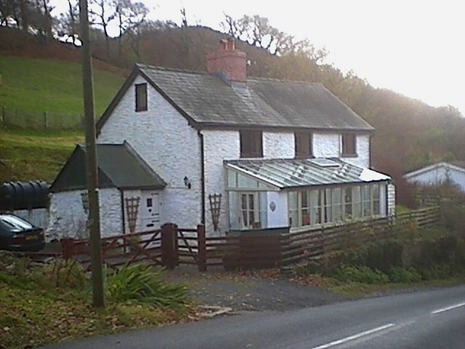
This delightful 3 or 4 bedroom, detached, welsh country cottage nestles in the foothills of the Cambrian Mountains right in the heart of the Welsh countryside. It has one acre of grounds and is surrounded by awesome natural beauty. Opposite the cottage is woodland and a gently flowing stream and there are numerous footpaths for walkers. Bird-watchers will appreciate the Red Kites and Buzzards regularly seen in the area, as well as woodpeckers, nuthatch, tits, finches and many other garden birds.

The Rhiw (pronounced “Roo” to the English ear and meaning a hill, or mound) has been a family home since 2002, but for many years it has been a highly popular self-catering holiday cottage, ideally located in the very heart of Wales. 1 hour’s drive from Aberystwyth on the coast and less than an hour to the English border towns and villages near Hereford, it takes less than 2 hours by car to reach North Wales, whilst Cardiff and Swansea in the south are only an hour and a half away.

Locally there are numerous footpaths and bridleways through wonderful Welsh countryside. Immediately at the back of the property, a steep 5 minute walk brings you to a splendid “top-of-the-world” experience as you see mountain ranges on all sides and lush valleys sweeping away beneath you. The Rhiw sits comfortably in its surroundings.

The cottage is thought to be over 200 years old and retains much of its original character. An individually designed conservatory was added in 2003 and a newly fitted kitchen in 2002. Replacement windows were installed early in 2004 and all windows are double glazed.

Llanafan Fawr is a small hamlet with the renowned 12th century Red Lion Inn, and Church and a 3,200 year old Yew tree. The spa town of Llandrindod Wells is just 15 minutes drive away and the market town of Builth Wells is about 9 miles away with many facilities including schools, hospital, cinema/arts centre and both indoor and outdoor leisure facilities.

On the ground floor:
Large fitted beamed Kitchen (approx. 15’ x 11’6”) with flagstone floor, oil fired rayburn providing heating and hot water, LPG gas hob, and double electric built-in fan oven
Porch/utility room with plumbing for washing machine (approx. 5’6” x 9’6”)

Beamed living room with stone surround fireplace and multi-fuel stove. Dark oak floor and cottage door to stairs (approx. 18’3” x 14’4”)

Conservatory (approx. 20’6” x 6’4”) with door through from living room, side entrance part-glazed door and light oak floor. Splendid views of the Cambrian Mountains.
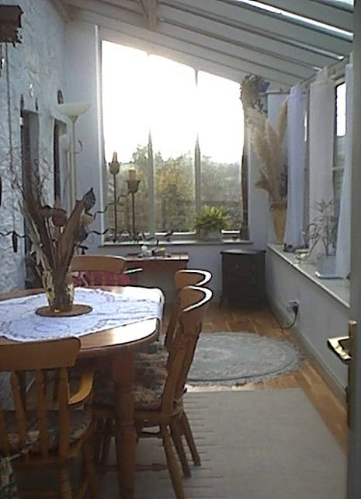
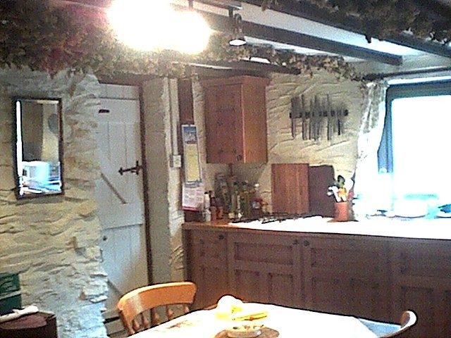
Conservatory Kitchen
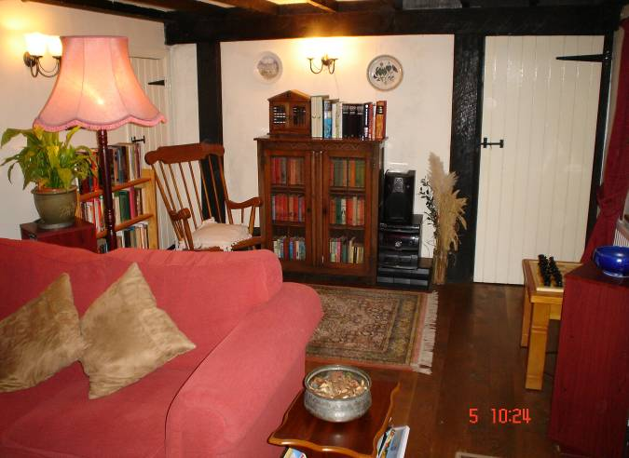
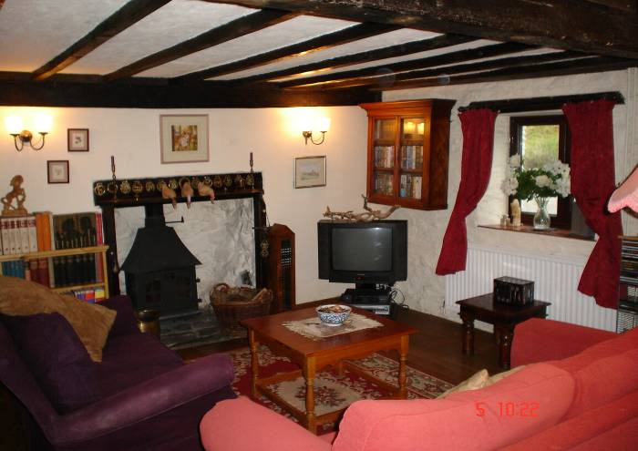
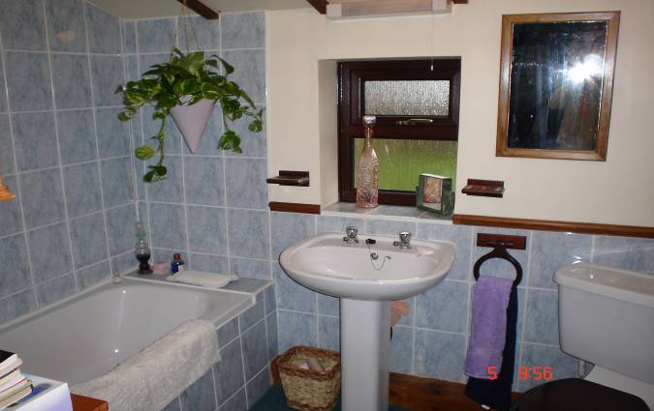
Lounge

Bathroom with panelled bath,
shower and WC

Stairs from lounge to Beamed landing,
wall lights and half-timbered clad walls

Bathroom
On the first floor:

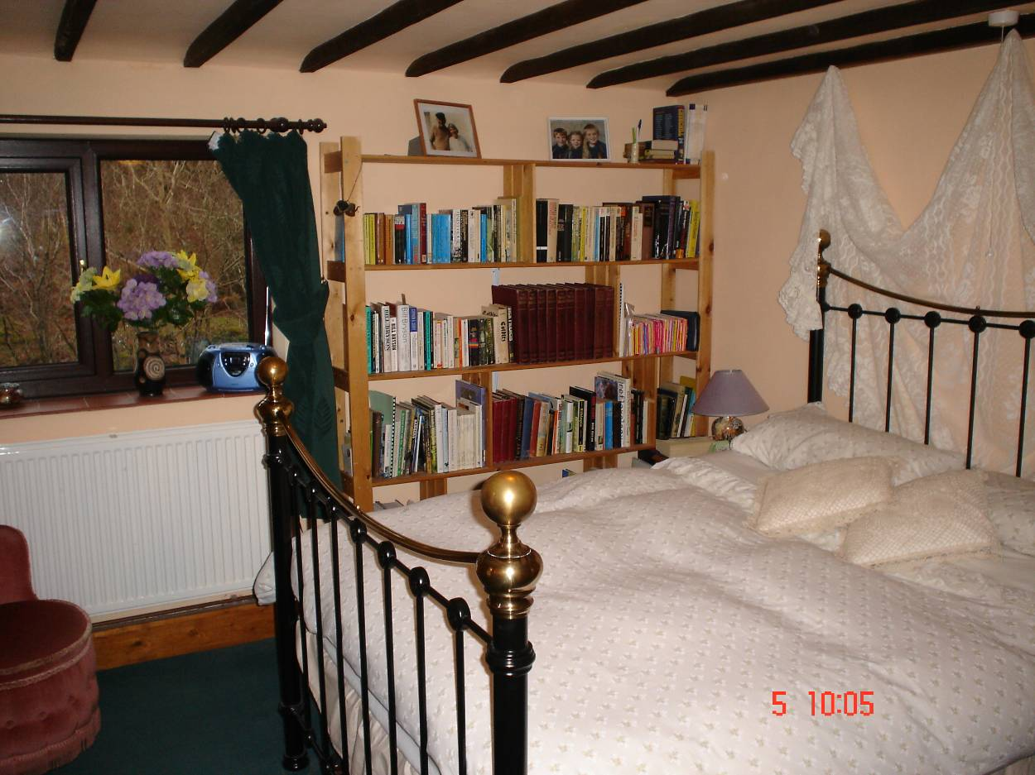

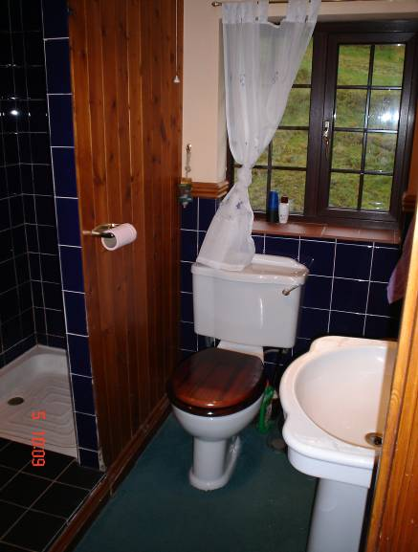
Bedroom 1
Bedroom 1 with en-suite shower room (approx. 10’8” x 10’6” plus ensuite shower and WC)
Built-in double wardrobe and shelving and fitted carpet

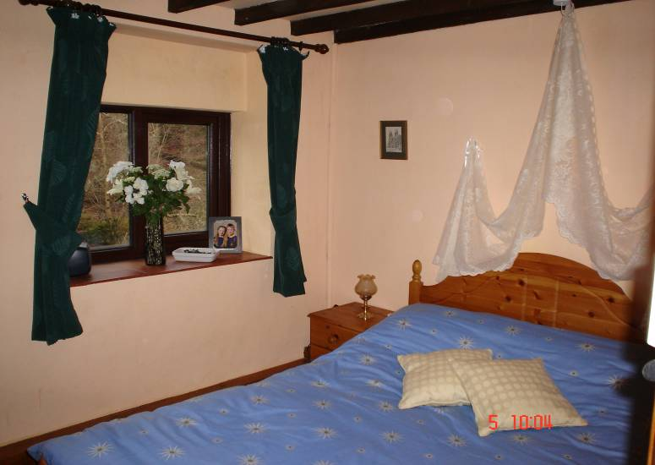

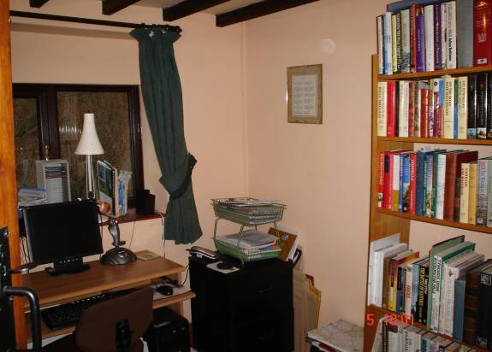
Ensuite

Bedroom 2 Bedroom 3/study

Bedroom 2 (approx. 10’ x 11’4”) Built-in double wardrobes and fitted carpet
Bedroom 3 (approx. 7’8” x 8’) with telephone point and fitted carpet. Used as office
Stairs from landing up to attic bedroom (approx. 11’6” x 9’) with restricted height. Wall lights, window and child safety-gate.
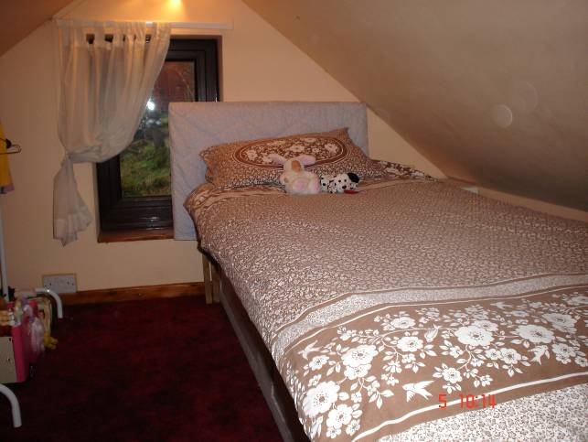
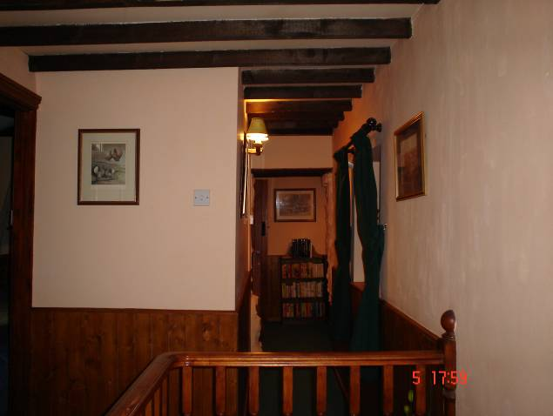
Attic bedroom Landing

Outside is one acre of grounds which has been carefully managed as a natural, wildlife garden. The garden includes a large garden shed, wildlife pond, barbecue area with brick built barbecue and a variety of shrubs and trees. There is a parking area sufficient for 3 cars with a wooden gate and side pedestrian gate. Further up the lane there is a metal field gate giving access to the property and including a public footpath which skirts the extreme edge of the property.

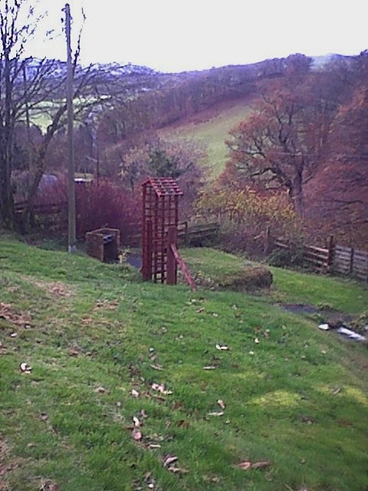
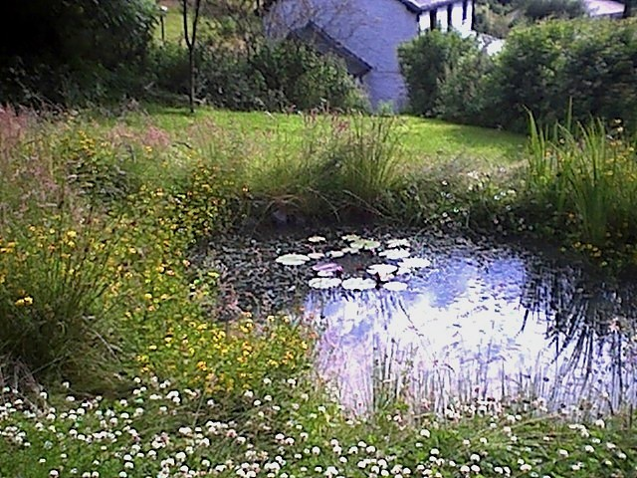
The Pond and grounds

Viewing by appointment Tel. 01591 620775
DIRECTIONS:
From Llandrindod Wells
Take the A4081 signed to Rhayader for approx. 2 miles till you see a left turn on to the B4358 towards Newbridge on Wye. Follow the B4358 through Newbridge on Wye turning right, then left towards Beulah. The Rhiw is on the left of the B4358 approx. 2 miles after The Red Lion pub at Llanafan Fawr and approx. 3 miles before Beulah. OS Map ref. 954534.
From Builth Wells
Take the A483 towards Llandovery as far as Beulah (approx. 7 miles) then turn right on to the B4358 towards Newbridge on Wye. The Rhiw is to be found on the right approx. 3 miles up this road. OS Map ref. 954534.

